Name: Abhinay P
Domain: Data Analyst
Project: Twitter Analytics Dashboard-Power BI
Task 5: Develop a visualization that compares the number of replies, retweets, and likes for tweets that have received media engagements greater than the median value. Include a filter for tweets posted in between June and august of 2020 and this graph should work only between 3PM IST to 5PM IST and 7 AM to 11AM apart from that time we should not show this graph in dashboard itself and tweet date should be odd number and media views should be even number as well as tweet character count should be above 20 and need to remove word which has letter “S”.
Data preparation and filtering logic:
To meet the task requirements, several calculated columns and filters were applied to the dataset. Tweet text was first processed to remove only those words containing the letter “s”, without removing the entire tweet. The cleaned text was then used to calculate the tweet character count, ensuring that character-based filtering was performed on the correct version of the text.
Tweet timestamps were converted to IST to correctly evaluate time-based conditions. From this, the tweet date and hour were derived to support date parity checks and restricted time windows. Media engagement values were analyzed to calculate the median media engagement, which served as a benchmark to identify higher-performing tweets.
Conditions applied:
The visualization includes only tweets that satisfy all the following conditions simultaneously:
- Media engagements are greater than the median value
- Tweet posted between June 2020 and august 2020
- Tweet date is an odd-numbered calendar day
- Media views are an even number
- Tweet date count is greater than 20 after removing the word containing letter ’s’
- Tweet posted only during the following IST time: 7AM to 11 AM and 3PM to 5PM
Visualization design:
A clustered column chart was selected for this task, as it is best suited for comparing multiple interaction metrics replies, retweets and likes side by side for same group of tweets. The Y-axis represents the total count of each interaction type, while the bars represents the three-engagement metrics.
Result and observation:
After applying all conditions simultaneously, no tweets satisfied every requirement. As a result, the clustered column chart appears blank. The outcome is not due to a modeling or visualization error but is a direct consequence of the strict filtering logic applied to the dataset.
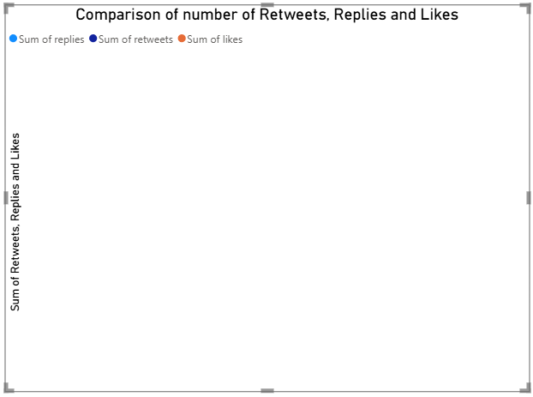
The blank chart confirms that the business rules were enforced correctly and that the dataset does not contain any tweets that meet all specified criteria within the given date range and time windows. This is a valid analytical result and reflects real-world scenarios where strict constraints can significantly reduce or eliminate qualifying data.
Conclusion:
This task demonstrates the importance of rigorous filtering and validation in analytical reporting. By applying median-based thresholds, content cleaning, parity checks, time-based visibility rules, and date constraints, the analysis ensures high data integrity. Although the final visualization contains no bars, the result itself is meaningful, as it confirms that no tweets met all conditions simultaneously. The outcome highlights the impact of strict business rules on data availability and reinforces the importance of validating assumptions before drawing conclusions.

